Substance Abuse Prevention
Skills Training (SAPST)
Building Our Behavioral Health Workforce

Trainer Preparation Guide
(List of Materials & Easel Paper)

General Materials Needed
Participant manual/binders (1 per participant)
Color data graphs from Session 2 (Worksheets 2.5 & 2.7), if participant materials are printed in black/white
Name badges (preprinted or write-on adhesive)
3 Pads of easel paper (with sticky strip on the back or bring tape)
Color Markers for writing on easel paper (one set of 3 per table, including the trainers’ table)
Black markers, such as a Sharpie (1 for each participant)
Sticky note pads in three sizes:
10 small (1.5” x 2”), and
10 regular (3” x 3”) and
4 large (5” x 7”)
- If large sticky paper cannot be found, colored paper in three colors is fine.
- Each of the 4 large pads should each be of a different color.
- 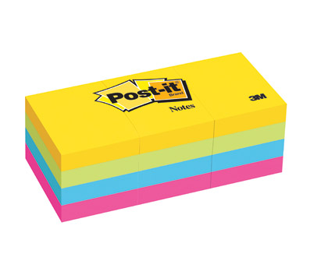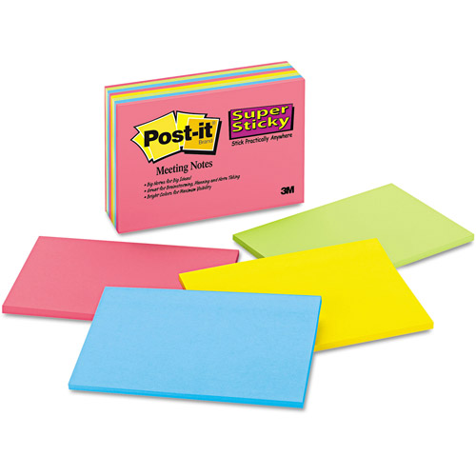
- 1.5 x 2.0 3.0 x 3.0 5.0 x 7.0

A ball of yarn (Please make sure the yarn is in the shape of a ball. It will be used in a throwing activity.)
Optional: consider having tactile toys for participants (i.e. clay, mini koosh balls)
Audiovisual Equipment Needed
Projector
Extension cords/multiple outlet strip
Large screen
Computer
Lavalier microphone and sound system (if room is large)

Room Setup
Round or rectangle tables to facilitate small group activities (Pods of 4-5 participants at each table is ideal)
Instructor table in the front to hold instructor materials and laptop for projection
If possible, “free flow” space in the room to facilitate “move and stand” activities

The Trainers will be responsible for:
Trainer PowerPoint presentations uploaded to computer (4 sessions total—1 per day)
Curriculum Review PowerPoint slide show (optional for the end of Session 4)
Reference books: 1) Prevention Mental, Emotional, and Behavioral Disorders Among Young People; 2) Clinical Manual of Prevention in Mental Health
Attendance Sheet (a standard template is provided, trainer may provide other)
Post Training Evaluation Survey (a standard template is provided, trainer may provide other)

The Trainers should prepare the following for each day of the presentation:

SESSION 1
An Introduction to the SAPST
- Easel Paper:
  - Title paper: Expectations. Write down responses to discussion and refer back throughout the training.
  - Title paper: Learning Environment Guidelines. Write down responses from discussion and refer back throughout the training as needed.
  - Title paper: Parking Lot. Keep up in the room and create a list throughout the training to be addressed later or outside of the training. Check this list at the end of each day for any follow-up needed with individual participants.

Setting the Foundation
- Easel Paper:
  - For Behavioral Health slide: Write down the definition for participants to refer back to throughout the training, “Behavioral Health is a state of mental/emotional being and/or choices and actions that affect wellness.”
  - Draw Continuum of Care image on easel paper and post it on the wall (may also want to print this as a poster prior to the training and bring along).
  - For Promotion slide: Write down the definition of promotion, “Promotion involves interventions (e.g., programs, practices, or environmental strategies) that enable people “to increase control over, and to improve, their health.”
  - For Prevention slide: Write down the definition of prevention, “Interventions that occur prior to the onset of a disorder and are intended to prevent or reduce the risk for the disorder.”
  - For Public Health Approach slide: May want to list the Public Health Key Characteristics and/or the Public Health Questions to refer back to.
  - For 10 Factors Activity: Label 3 sheets of easel paper – Individual, Family, School/Community. Make 2 columns on each paper for Risk Factors and Protective Factors. Post these 3 sheets on a wall for the activity.
    - For a large group 6 sheets are needed: RF–individual, RF–family, RF–school/community, PF–individual, PF–family, PF–school/community.
- Sticky Notes & Markers (Sharpie): Set out on tables at lunch
  - 10 Factors Activity: Give each participant 10 sticky notes and a black marker.

Review
- Easel Paper:
  - Optional: Write Plusses and Wishes on separate pieces of paper and discuss with the group what they liked (plusses) and wish for the next day (wishes).
SESSION 2
- Easel Paper:
  - Make sure that Introduction and Expectations, Learning Environment Guidelines, and Parking Lot easel papers are hung up in the room. You may want to refer to these at the beginning of this session.

Step 1: Assessment
- Easel Paper:
  - For Epidemiology slide: Write the definition of epidemiology on easel paper. “Epidemiology is concerned with the distribution and determinants of health and diseases in populations.”
  - For Health disparities slide: Write the definition of health disparities on easel paper to refer to during the discussion, “A “health disparity” is a difference in health that adversely affects groups of people AND that is closely linked with social, economic, and/or environmental disadvantages. Health disparities adversely affect groups of people who have systematically experienced greater obstacles to health based on their racial or ethnic group; religion; socioeconomic status; gender; age; mental health; cognitive, sensory, or physical disability; sexual orientation or gender identity; geographic location; or other characteristics historically linked to discrimination or exclusion.”

Step 2: Capacity
- Easel Paper:
  - For Resources slide: Ask participants for examples of fiscal resources, human resources, and organizational resources. Write these down on easel paper.
  - Identifying Resources Activity: Put up three sheets of paper on the wall: one labeled “Human Resource”, another labeled “Fiscal Resources” and the third labeled “Organizational Resources.”
- Sticky notes & Markers (Sharpies)
  - For Identifying Resources Activity: Ask participants to individually identify a community where they work or live in and then have them identify the resources—human, fiscal, and organizational—that are connected to underage drinking in that community. Write down the different resources on separate sticky notes (must be large size sticky notes and a Sharpie type pen for readability) Ask them to put their sticky notes on the paper with the appropriate category.

SESSION 3
- Easel Paper:
  - Make sure that Introduction and Expectations, Learning Environment Guidelines, and Parking Lot easel papers are hung up in the room. You may want to refer to these before beginning the day.
  - Make sure that the behavioral health definition is posted to refer to during the day.

Building Capacity
- Easel Paper:
  - For Building Capacity: Engaging Stakeholders slide: Ask participants who they would consider potential stakeholders and write down their responses.
- For Building Capacity: Strengthening Collaborative Groups slide: Visually show the different sectors that could be represented by drawing 3 circles on easel paper, one inside the other—the smallest, inner circle represents those who are most interested or have a natural affinity towards the issue (e.g. police); the other circles represent those less interested (e.g. business). If participants don’t mention mental health, violence prevention, teen pregnancy prevention, or school dropout prevention, ask them which circle these groups would go in and why.

- Tape & Large Labeled Sticky Notes
  - Optional Levels of Involvement Activity: Put tape on floor in the shape of steps (five steps), and label five large sticky notes one of the different levels of involvement and put the sticky notes on the appropriate step on the floor.

Cultural Competency
- Easel Paper:
  - For Culture Can Be Defined By slide: Write the definition of culture on easel paper: “Culture refers to integrated patterns of human behavior that include the language, thoughts, communications, actions, customs, beliefs, values, and institutions of racial, ethnic, religious or social groups.”
  - For Cultural Competence slide: Write the definition of cultural competence on easel paper: “ Cultural competence implies having the capacity to function effectively as an individual, an organization, or a system within the context of the cultural beliefs, behaviors, and needs presented by consumers and their communities.”

Step 3: Planning
- Easel Paper:
  - For Prioritizing Risk Factors Case Study Activity: draw an Importance/Changeability grid with 4 quadrants – high and low importance, and high and low changeability. Have each group write their risk factor on a large sticky note and place it in the appropriate box.

SESSION 4
- Easel Paper:

  - Make sure that Introduction and Expectations, Learning Environment Guidelines, and Parking Lot easel papers are hung up in the room to refer to.

Sustainability
- Easel Paper:

  - For A Parable of Sustainability slide: write the definition of sustainability on easel paper, "Sustainability is the process of an effective system achieving and maintaining desired long-term results."

Evaluation
- Easel Paper:
  - For Evaluation introduction slide: Write the following statements on easel paper for discussion: “When I think about evaluation, I feel…”, “The challenges of evaluation are…”, and “The benefits of evaluation are…”
  - For Determining Outcomes Activity: draw the logic model from the previous slide on a piece of easel paper. Also fill in the box under behaviors/related problems, and also the box under long-term outcomes, using the information from the previous slide. An alternative is to use the slide screen for this activity with the logic model that is behind the activity instructions. When participants are done, ask each group to post their risk factor, intervention, and short-term outcomes on the logic model on the easel paper (or slide screen).
  - For Reporting Evaluation Results slide: Write on easel paper the responses to the discussion question, “What are other groups of people who will need to see the evaluation results?”

Bringing It All Together
- Optional Curriculum Review PowerPoint slide show:

  - For Review Curriculum slide: put the Curriculum Review slideshow on your computer, if you decide to show it.

- Easel Paper:

- For Review Your Expectations slide: Make sure that the easel paper with Expectations from the first day is hung up in the room and easy to see. Refer to this, re-reading the expectations, then ask participants to consider the four questions on the slide and share their responses with the group.

- Yarn:

Optional Web Activity: the ball of yarn will be passed from one person to the next, each holding onto a piece of it to create a “web” connecting the participants together.
Summary Table of Easel Paper

Chapter | Slide Number | Need
1 | 6 | Expectations title
1 | 7 | Guidelines title with pre-written items
1 | 8 | Parking Lot
1 – extra | 8 | Abbreviations list
1 | 13 | Write definition of Behavioral Health
1 | 15 | Draw Continuum of Care Model
1 | 16 | Write down definition of Promotion
1 | 17 | Write down Explanation of Prevention according to IOM
1 - extra | 18 | Write down definitions and examples of U, S and I
1 | 21 | Write down definition of Public Health from IOM
1 | 26 | Label 6 sheets writing one label on each sheet:  - Individual Risk Factors  - Individual Protective Factors  - Family Risk Factors  - Family Protective Factors  - Community Risk Factors  - Community Protective Factors
1 | End | Pluses and Wishes title
2 - extra | 6 | Draw the SPF diagram
2 - extra | 9 | Draw logic model
2 | 12 | Write down the definition of Epidemiology
2 | 13 | Write down full definition of Health Disparities from Healthy People 2020
2 - extra | 21 | Write definitions of magnitude, time trend, severity and comparison
2 | 30 | Label three sheets of paper:  - Human Resource  - Fiscal Resources  - Organizational Resources
2 | 32 | Draw High Low table
3 – extra | 13 | Write definition of cultural
3 – extra | 13 | Write definition of cultural competence
3 | 28 | Draw Changeability and Importance Box from Worksheet 3.10
4 - extra | 5 | Definition of sustainability
4 | 22 | Write on 1 sheet:  - When I think about evaluation, I feel…  - The challenges of evaluation are…  - The benefits of evaluation are…

