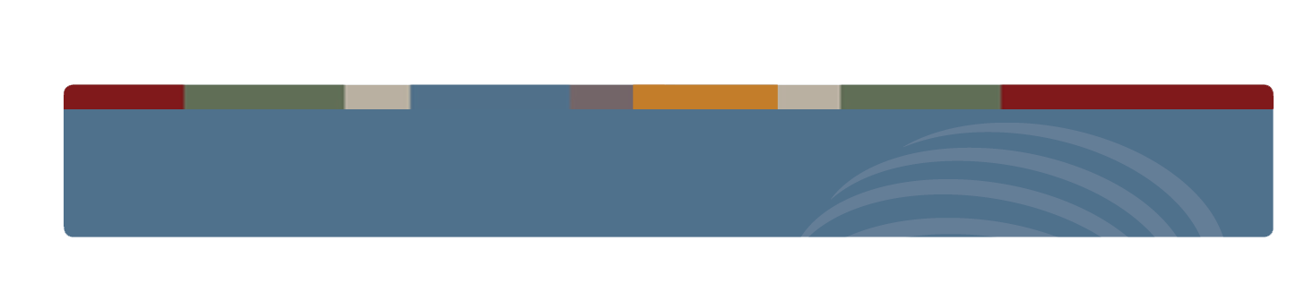

**SAMHSA’S CENTER FOR THE APPLICATION OF PREVENTION TECHNOLOGIES**

**Substance Abuse Prevention Skills Training Session 2**

## AGENDA

#### Review Key Concepts from Session 1

* **Strategic Prevention Framework**
  + **Step 1: Assessment**
  + **Step 2: Capacity**

**LEARNING OBJECTIVES**

* **By the end of this session, you will be able to:**
  + **Describe how to assess substance use problems and related behaviors**
  + **Explain how health disparities relate to prevention**
  + **Describe how to assess risk and protective factors that influence (or contribute to) the problems**
  + **Explain how to assess a community’s readiness and resources to address its problems**

**INDEX OF HANDOUTS**

Information Sheet 2.1: Key Concepts for Step 1 Information Sheet 2.2: Types of Data

Information Sheet 2.3: Pros & Cons of Data Collection Methods Information Sheet 2.4: Data Sources

Worksheet 2.5: Case Study Activity – Looking at Data Information Sheet 2.6: Tips for Examining Data

Worksheet 2.7: Case Study Activity – Choosing the Problem Information Sheet 2.8: Examples of Data to Collect

Worksheet 2.9: Activity – Match Up Information Sheet 2.10: Assessing Capacity

Worksheet 2.11: Case Study Activity – Determining Resources and Readiness

**INFORMATION SHEET 2.1 – KEY CONCEPTS FOR STEP 1**

**Understanding Assessment**

To change a problem, you must first understand it. The assessment step is sometimes referred to as “assessing needs” (or “needs assessment”) because the data collected during the assessment will reveal what a community, state, tribe, or jurisdiction needs in order to prevent substance abuse and promote wellness.

Assessment involves gathering the following data:

* Nature and extent of substance use problems and related behaviors (this refers to substance use *consequences* and *consumption*, terms that may be more familiar)
* Risk and protective factors that influence substance use problems and related behaviors
* Available resources and readiness of the community to address these problems

Using data allows for a more objective decision-making process. The assessment should be able to answer the following questions about substance use:

* What problems and related behaviors are occurring?
* How often are the problems and related behaviors occurring?
* Where are these problems and related behaviors occurring?
* Which population groups experience more of these problems and related behaviors?

Some population groups are at greater risk than others, and thus experience disproportionate substance abuse problems. During the assessment process, you will need to collect data on these vulnerable populations, even if it is not readily available.

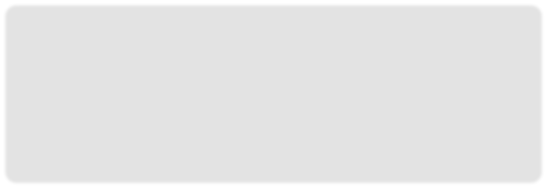

A **health disparity** is a difference in health that is “closely linked with social, economic, and/or environmental disadvantages. Health disparities adversely affect groups of people who have systematically experienced greater obstacles to health based on their racial or ethnic group; religion; socioeconomic status; gender; age; mental health; cognitive, sensory, or physical disability; sexual orientation or gender identity; geographic location; or other characteristics historically linked to discrimination or exclusion.”1

While substance abuse interventions usually don’t address these disadvantages directly, they often do address the factors that contribute to these disadvantages.

#### Epidemiology

Epidemiology is concerned with the *distribution* and *determinants* of health and diseases, sickness, injuries, disabilities, and death in populations.i In assessments, epidemiology is used to describe the problem. The data collected will tell you the following:

* What the problems and related behaviors are
* How many are experiencing the problems and engaging in the behavior
* Who is affected most (which population group)
* Where and when it is occurring
* What factors are contributing to the problem

**Distribution** reveals the varying *frequency* and *pattern* of disease occurrence from one population group to another.ii Distribution can help us understand what the problems and related behaviors are by providing information related to:

* Pattern: How do the problems occur?
  + Time (e.g., annual and seasonal occurrence, daily or even hourly occurrence)
  + Place (e.g., geographic variation, urban-rural differences, school or work location)
  + Personal characteristics (e.g., age, sex, race, marital status, socioeconomic status, behaviors, and environmental exposures)
* Frequency: How often do the problems occur?
  + Incidence – How many *new* cases are there? (i.e. number of *new* cases of a disease in a specific period of time) iii
  + Prevalence – Within a population or group of people, how many of them have the disease? (i.e. number of existing or current cases in a population)iii

**Determinants** refer to the risk and protective factors that influence problems and are capable of bringing about a change in health. For example, risk factors for underage drinking include laws and social norms (the expressed or implied rules indicating what behavior is acceptable) that are favorable towards alcohol use. A protective factor is parental monitoring.

The data that communities collect are commonly referred to as “data indicators” because they indicate the level of the problem. Communities can use these epidemiological data to compare the severity of problems and allocate scarce prevention resources.

#### Logic Model

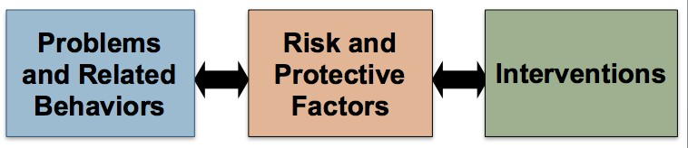

Logic models connect problems and related behaviors to (1) the specific local factors that influence or contribute to them, and (2) the interventions that will be used to address the risk and protective factors related to the problems and behaviors.

* **Assessment** is the first step in the strategic planning process.
* **Epidemiology** is *how* we do the assessment.
* **Logic model** is our “road map”—the first stop is assessing problems and related behaviors.

## INFORMATION SHEET 2.2 – TYPES OF DATA

#### Quantitative Data

**Quantitative data** indicates how often a behavior/event occurs or to what degree it exists.

* It can provide the answers to “How many?” and “How often?”
* It is typically described in “numbers.”
* It can be used to draw general conclusions about a population, such as the level of youth alcohol use in a community.
* Examples of methods for obtaining quantitative data include random sample surveys and archival sources.

#### Qualitative Data

**Qualitative data** explains why people behave or feel the way they do.

* It can help provide the answer to “Why/Why not?” or “What does it mean?”
* It is usually described in “words.”
* It can be used to examine an issue or population in more depth to understand underlying issues, such as the way in which community norms contribute to the level of youth alcohol use.
* Examples of methods for obtaining qualitative data include surveys with open-ended questions and focus groups.
* Qualitative data can be very useful when communities do not have quantitative data (numbers), particularly for certain at-risk groups (e.g., homeless, LBGT, and some minority groups like tribes).

Communities may not have *quantitative* data available, particularly for certain at-risk groups (e.g., homeless; lesbian, gay, bisexual, or transgender individuals, some minority groups like tribes). In these situations, *qualitative* data can be very useful.

Many epidemiologists and evaluators actually recommend collecting both quantitative and qualitative data. This mixed-method approach provides a much more in-depth understanding of the population groups being assessed because it allows you to collect the same information across several individuals and/or groups (or other units of measure). In addition, quantitative approaches typically generate responses to questions that are created by the researcher, whereas qualitative approaches typically elicit more open-ended responses that are generated by the respondents. So combining the two approaches offers a way to understand the quantitative data from the perspective of the respondent.

**INFORMATION SHEET 2.3 – PROS & CONS OF DATA COLLECTION METHODS**

|  |  |  |  |
| --- | --- | --- | --- |
| **Method** | **Description** | **PROS** | **CONS** |
| **Surveys** | Standardized paper-and-pencil or phone questionnaires that ask pre-determined questions | * Can be highly accurate * Can be highly reliable and valid * Allows for comparisons with other/larger populations when items come from existing instruments * Easily generates quantitative data | * Relatively high cost * Relatively slow to design, implement, and analyze * Accuracy depends on who and how many people are sampled * Accuracy limited to willing and reachable respondents * May have low response rates * Little opportunity to explore issues in depth |
| **Archival** | Data that have already been collected by an agency or organization and which are in their records or archives | * Low cost * Relatively rapid * Unobtrusive * Can be highly accurate * Often good to moderate validity * Usually allows for historical comparisons/trend analysis * Often allows for comparisons with larger populations | * May be difficult to access * Often out of date * When rules for record-keeping are changed, makes trend analysis difficult or invalid * Must learn how records were compiled to assess validity * May not include data on knowledge, attitudes, and opinions * May not provide a complete picture of the situation |
| **Key Informant Interviews** | Structured or unstructured, one-on-one directed conversations with key individuals or leaders in a community | * Low cost (assuming relatively few) * Respondents define what is important * Rapid data collection * Possible to explore issues in depth * Opportunity to clarify responses through probes * Sources of leads to other data sources and other key informants | * Can be time-consuming to schedule interviews with busy informants * Requires skilled/trained interviewers * Accuracy (generalizability) limited and difficult to specify * Produces limited quantitative data * May be difficult to analyze and summarize findings |
| **Focus Groups** | Structured interviews with small groups of like individuals using standardized questions, follow-up questions, and exploration of other topics that arise to better understand participants | * Low cost * Rapid data collection * Participants define what is important * Some opportunity to explore issues in depth * Opportunity to clarify responses through probes | * Can be time consuming to assemble groups * Produces limited quantitative data * Requires trained facilitators * Less control over process than key informant interviews * Difficult to collect sensitive information * Accuracy (generalizability) limited and difficult to specify * May be difficult to analyze and summarize findings |

**INFORMATION SHEET 2.4 – DATA SOURCES**

Following is a list of national, state, and local sources that have data that might be useful to communities conducting an assessment.

#### National Data Sources

***Behavioral Risk Factor Surveillance System (BRFSS),* Centers for Disease Control and Prevention (CDC)**

[www.cdc.gov/brfss/](http://www.cdc.gov/brfss/)

This annual survey, developed in 1984, collects demographic data on adults and information on alcohol use. The sample is national. States can add their own questions.

***Monitoring the Future (MTF),* National Institute on Drug Abuse**

[www.monitoringthefuture.org](http://www.monitoringthefuture.org/)

MTF is an annual survey of the “behaviors, attitudes, and values” of young people. Information is available on the incidence and prevalence of substance use, as well as other related issues, including perceived harm, disapproval of use, and perceived availability. It has a national sample; regional data are also available. MTF began in 1975 with high school seniors and graduates, and in 1991 8th and 10th graders were added. There is also a follow-up sample of college-age and young adults.

***National Survey on Drug Use and Health (NSDUH),* Substance Abuse and Mental Health Services Administration (SAM HSA)**

[www.oas.samhsa.gov/nsduh.htm](http://www.oas.samhsa.gov/nsduh.htm)

NSDUH is an annual survey, developed in 1973, that mainly looks at the incidence and prevalence of alcohol and drug use among different age groups. Data is collected from household members and sorted by ages: 12–17, 18– 25, 26–34, and over 35. A national sample is used; regional and state data are also available.

***Youth Risk Behavior Surveillance System (YRBSS),* Centers for Disease Control and Prevention**

[www.cdc.gov/nccdphp/dash/yrbs](http://www.cdc.gov/nccdphp/dash/yrbs)

The YRBSS assesses teenagers’ incidence and prevalence of substance use, as well as other health issues, including sexual activity, vehicle safety, weapons, violence, and suicide. It measures behavior versus knowledge/attitudes. YRBSS uses a national sample of students in grades 9–12; some state and local data are also available. Developed in 1990, its national school-based version is biennial; Tribes and states vary.

***Fatal Accident Reporting System (FARS),* National Highway Traffic Safety Administration**

<http://www-fars.nhtsa.dot.gov/Main/index.aspx>

Developed in 1994, *FARS* collects the following information annually from a national sample about deaths resulting from motor vehicle collisions: alcohol and drug involvement and major demographic characteristics.

***Drug Abuse Warning Network (DAWN),* Substance Abuse and Mental Health Services Administration**

[www.samhsa.gov/data/DAWN.aspx](http://www.samhsa.gov/data/DAWN.aspx)

DAWN collects information annually from a nationally representative sample of patients in hospital emergency departments and from deaths recorded in medical examiners’ reports about age, other demographics, and major substances of abuse. DAWN also produces special reports.

***National Longitudinal Study of Adolescent Health,* National Institute on Child Health and Human Development**

[www.cpc.unc.edu/projects/addhealth](http://www.cpc.unc.edu/projects/addhealth)

This is “a longitudinal study of a nationally representative sample of adolescents in grades 7–12 in the United States during the 1994–95 school year.” Information was collected on the influences of individual and environmental factors on health and health-related behavior in such areas as diet, physical activity, health service use, morbidity, injury, violence, sexual behavior, contraception, sexually transmitted infections, pregnancy, suicidal intentions/thoughts, substance use/abuse, and runaway behavior. Four follow-up surveys were conducted in 1996, 2001–2002, and 2007–2008. Information was also collected from parents, siblings, friends, romantic partners, fellow students, and school administrators.

***National Household Education Survey (NHES),* National Center for Education Statistics**

[www.nces.ed.gov/nhes](http://www.nces.ed.gov/nhes)

This is a survey about adult education and lifelong learning**,** civic involvement, early childhood education and school readiness, household library use, parent involvement in education, and school safety and discipline. It uses a national sample of household members, depending on the topic (i.e., parents of children in grades 3–12 and youth in grades 6–12 participated in the School Safety and Discipline survey). It was conducted in 1991, 1993, 1995, 1996, 1999, 2001, 2003, 2005, and 2007.

***National Crime Victimization Survey (NCVS),* Bureau of Justice Statistics**

[www.icpsr.umich.edu/NACJD/NCVS](http://www.icpsr.umich.edu/NACJD/NCVS)

This survey, conducted annually since 1973, collects data on the frequency and nature of rape, sexual assault, robbery, aggravated and simple assault, theft, household burglary, and motor vehicle theft. It uses a national sample of primarily adults, although youth data are also available.

***School Crime Supplement to the National Crime Victimization Survey,* National Center for Education Statistics and Bureau of Justice Statistics**

<http://www.icpsr.umich.edu/icpsrweb/NACJD/series/95/studies/28201?paging.startRow=26> This survey of household members who had attended school during the preceding six months

collects information about the experiences with and perceptions of crime and violence that occurred inside school, on school grounds, or on the way to or from school, as well as preventive measures used by schools and school rules, afterschool activities, availability of drugs and alcohol at school, and other related issues. It was conducted in 1989, 1995, 1999, 2005, and 2009, and uses the same national sample as the National Crime Victimization Survey.

***U.S. Census,* U.S. Census Bureau**

[www.census.gov](http://www.census.gov/)

This survey collects demographic data on adult household members, including population, race or ethnicity, age, income, education, and number of children. It is conducted every 10 years (interim estimates available) with national, regional, state, community, and census tract samples.

# State Data Sources

#### Center for Disease Control and Prevention (CDC): Sortable Stats

<http://www.cdc.gov/program/data/index.htm>

Sortable Stats is an interactive data set composed of 20 behavioral risk factors and health indicators. The site compiles state-level data for all 50 states and Washington D.C., from various CDC and other federal sources into a format that allows users to view, sort, and compare data by state, federal, or geographic regions; view data by demographic categories and historical trends for states; and save graphs and maps as images that depict state trends and incidence rates.

#### National Library of Medicine, National Information Center on Health Services Research and Health Care Technology

<http://www.nlm.nih.gov/hsrinfo/state_resources.html>

This site provides brief descriptions and links to a wide range of state-level data, tools, and statistics. In addition to links to specific state resources, links also are included to federal and other sources of state data.

# Local Data Sources

#### Community Epidemiology Surveillance Networks

These multi-agency work groups, which study the spread, growth, and development of drug abuse and related problems, can be an extremely valuable source of information for local prevention programs. They also provide a model for the collection of comprehensive local information on drug and alcohol abuse. For more information, see the National Institute of Drug Abuse publication *Assessing Drug Abuse Within and Across Communities: Community Epidemiology Surveillance Networks on Drug Abuse,* available online at [www.drugabuse.gov/pubs/assessing](http://www.drugabuse.gov/pubs/assessing).

#### Police Reports

Police incident and arrest reports are filed and maintained by local and state law enforcement agencies (including some private security agencies, such as university police departments). Incident reports are filed when no arrest is made or citation issued. Incident and arrest reports typically contain a great deal of narrative information. Although some jurisdictions maintain computerized summaries, abstracting these reports is extremely time-consuming. However, some departments may be willing to generate summaries of drug- and alcohol-related arrests and incidents. Some states also publish annual summaries based on these reports. For assistance with criminal justice data, contact your state’s Statistical Analysis Center. Contact information for these centers can be found online through the Justice Research and Statistics Association at [www.jrsa.org/sac/](http://www.jrsa.org/sac/).

#### School Incident Records and Discipline Reports

These narrative reports provide information on incidents and disciplinary actions in public schools, including those involving the use, possession, or sale of substances. Unfortunately, they can be difficult to access. Administrators are sometimes reluctant to share the reports, afraid that they will cast their school or district in a bad light. Also, the data are often aggregated at the building, district, and state levels. Obtaining access to the raw data in these files can be extremely difficult because of confidentiality issues. If you are granted access, you may then be expected to take special steps to protect the privacy of the individuals described by the data.

#### Court Records

Court records can provide information on juvenile controlled-substance offenses, such as drug possession, conspiracy, possession of a hypodermic needle, and possession near a school.

#### Medical Examiner or Coroner Data

Most states require a medical examiner’s or coroner’s report for each person whose death resulted from violence or injury. These reports often contain the results of tests administered to determine if the deceased had used drugs or alcohol at the time of death. The reports are collected by County and State Medical Examiner’s Offices, and County Coroner’s Offices. They are often not computerized.

#### Hospital Discharge Data

Hospital discharge data are collected on every person discharged from a hospital. These may be able to provide some information on injuries and diseases related to substance use. Some states aggregate these data at the state level. This information can be difficult to get from local hospitals and trauma registries, especially in light of confidentiality requirements and staff time required to make these data available.

#### Emergency Department Data

Activity records and medical logs are kept by hospital emergency departments. They may contain information on whether an emergency department visit was drug- or alcohol-related (although this determination may be arbitrary). Emergency department data may be more useful than discharge data, given the nature of most drug-related medical incidents. However, like hospital discharge data, these data may be difficult to obtain.

#### Emergency Medical Service Data

“Trip reports” or “run logs” maintained by emergency medical and ambulance services every time they transport a patient may include information on whether the incident was drug- or alcohol- related. This information is often not aggregated in a Jurisdiction, sometimes not computerized, and, as with all medical information, subject to confidentiality requirements.

#### Treatment Data

Every state keeps records of those entering substance misuse treatment, including age, gender, race/ethnicity, primary drug and zip code or city/town/county. This is collected by the state Department of Health or Behavioral Health and is helpful in determining substance misuse trends in the local community.

#### Newspapers

While not scientific, using “newspaper epidemiology” to identify the scope and nature of local drug and alcohol problems can provide a valuable and compelling picture of your community. Pay special attention to drug- and alcohol-related crimes, as well as the police report section of the newspaper in smaller communities. Many newspapers now have online archives, which allow their articles to be searched. Commercial database providers can also search newspapers by topic. Your local library (or local college library) may be able to help you conduct such a search.

**WORKSHEET 2.5: CASE STUDY – LOOKING AT DATA: COMMUNITY XYZ**

#### Purpose of Activity –

To provide the opportunity to look at substance abuse data and to examine the distribution of a behavior in a population.

#### Background –

You are a member of a Substance Abuse Prevention Task Force in Community XYZ. This community is located in an urban setting and has a population that is 76% white, 15% Latino, 6% African American, and 3% Asian/Pacific Islander.

The task force has been in existence for the past seven years and consists of 25 parents, a representative from the mayor’s office, a pediatrician, several representatives from the Women’s Guild (an organization for women over age 65), representatives from a Health Task Force serving the Latino community, local artists, a newspaper reporter, and youth from the local church youth group.

The task force has collected data on the problem of alcohol and other drug use.

#### Instructions –

1. Your subcommittee will be looking at the data collected by the task force.
2. In small groups, review the data charts on the next page. They illustrate the following:
   * Percentages of 9th- and 12th-grade students in Community XYZ compared to Any-State who had at least one drink in the past 30 days
   * Percentages of 9th- and 12th-grade students by gender in Community XYZ who had at least one drink in the past 30 days
3. In your groups, answer the following questions about the data (write your responses below):

* **What conclusion can you draw from looking at the data?**
* **What additional questions do you have?**
* **What additional data might you want to collect or look at?**

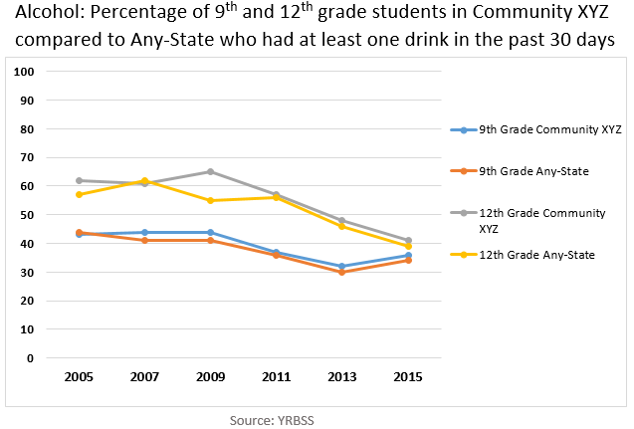

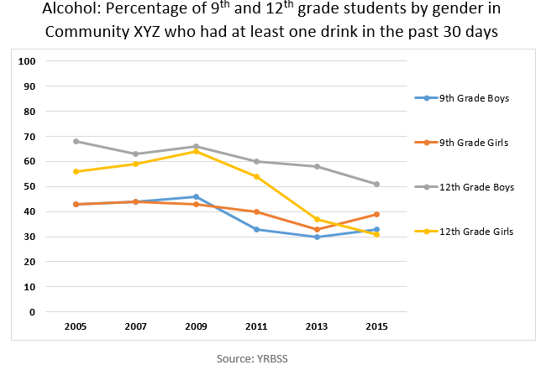

**INFORMATION SHEET 2.6 – TIPS FOR EXAMINING DATA**

**Comparisons**

Comparing your data to other existing data provides a context for understanding your assessment results. For example, survey data from a high school may seem, at a glance, to reveal high smoking rates among 9th graders. However, a comparison of these data to statewide data might actually show that your school’s smoking rates are much lower than the statewide average.

When examining data, it’s useful to make comparisons in some of the following ways:

* + Between the community now and sometime in the past
  + Between the community and the state (or similar communities)
  + Among different population groups in the community, including different age groups and genders

For example, you can look at data from an indicator such as 30-day alcohol use and draw comparisons in different ways. For instance, you can compare it to the past and discover that your community has a lower or higher rate than it did previously. Or when comparing it to the state, you might discover that your community has a lower or higher rate than your state. When you compare population groups, you may notice whether there is a higher rate among males than females, or a lower rate among 14-year-olds than among 17-year-olds.

When looking at data and making comparisons, be careful using small numbers to calculate rates—they may cause rates to appear exaggerated.

**Rates –** In epidemiology, rates are a measure of the frequency with which a health event occurs in a specific population over a period of time. Rates are used to standardize data in order to be able to compare it across different population sizes.

For example, a town with a population of 30,000 has 500 arrests in a given year for driving under the influence (DUIs). Divide 500 by 30,000 to get a rate of .017 arrests per person per year. To make the rate easier to understand, multiply by 1,000—now you can say that the rate of DUIs for the town is 17 per 1,000 people per year.

The following calculation provides a rate per 1,000 people per time period: Rate = Number of cases x 1,000

Population over time period

For national data sources or larger population sizes, the rate is often calculated with 10,000 or 100,000 population size. You can multiply by whatever size makes sense for your community.

**Small numbers** – When rates or percentages are calculated using small numbers, they may appear more exaggerated. For example, a 100% increase in motor vehicle accidents from 2003 to 2006 in Smithtown would sound like a lot of accidents. However, what if there had been one motor vehicle accident in 2003 and two in 2006? Although, still a 100% increase, the severity is greatly diminished.

Small numbers can sometimes be misleading, as this example illustrates, when they are used to calculate percentages. A small number as a percentage may lead us to believe that there has been a significant increase, but when we look at the actual numbers we see that the increase is very small.

Low, or even very low, percentages of some behaviors may be significant, however, and should not be dismissed as unimportant, especially if the behavior has severe consequences.

# Things to Remember

* + **Examine different kinds of data** – Substance use and other behavioral health problems are complex, so understanding them requires looking at different kinds of data, both quantitative and qualitative, to get an accurate and complete picture of the problems.
  + **Look for relationships and patterns** – Numbers alone have no meaning, so look for patterns over time, as well as relationships between data.
  + **Notice any data gaps** – After determining what data exists, you may discover “gaps” in the data or that you need additional data to answer certain assessment questions.
  + **Be aware that not all data are equal** – Some data are more valid and available than others. You may need to use qualitative data to fill in some of your data gaps. Keep in mind that these data are less objective.

**Comparison** is one of the criteria to consider when determining which problem(s) to address. Other criteria can include:

**Magnitude** – Which problem seems to be the largest? (Be careful of small numbers.)

**Time trend** – Is the problem getting worse over time or is it getting better over time?

**Severity** – What is the severity of the problem? Is it resulting in mortality? Is it more costly?

***Make sure you collect data on these criteria.***

## WORKSHEET 2.7: CASE STUDY – CHOOSING THE PROBLEM: COMMUNITY XYZ

#### Purpose of Activity –

To provide the opportunity to compare alcohol and marijuana use data, and select which problem to address.

#### Background –

You are a member of a Substance Abuse Prevention Task Force in Community of XYZ. This community is located in an urban setting and has a population that is 76% white, 15% Latino, 6% African American, and 3% Asian/Pacific Islander.

The task force has been in existence for the past seven years and consists of 25 parents, a representative from the mayor’s office, a pediatrician, several representatives from the Women’s Guild (an organization for women over age 65), representatives from a Health Task Force serving the Latino community, local artists, a newspaper reporter, and youth from the local church youth group.

The task force has collected data on the problem of alcohol and other drug abuse.

#### Instructions –

1. Your subcommittee has been asked to look at and compare alcohol-related and marijuana- related data.
2. Review the marijuana data in the charts on the next page. They illustrate the following:
   * Percentages of 9th- and 12th-grade students in Community XYZ compared to Any-State who have used marijuana at least once in the past 30 days
   * Percentages of 9th grade students by gender in Community XYZ who have used marijuana at least once in the past 30 days
3. In your groups, answer the following questions about the data (write your responses below):

#### What conclusion(s) can you draw from looking at the data?

* + **What additional data might you want to collect or look at?**

1. Compare the marijuana data to the alcohol data in the charts on the following pages, and answer these additional questions:

* **What conclusion(s) can you draw from comparing the marijuana and alcohol data?**
* **Which problem would you select to address and why? (Provide reasons based on what you’ve learned so far.)**
* **Was there any additional information that you would have liked to see? (Please describe.)**

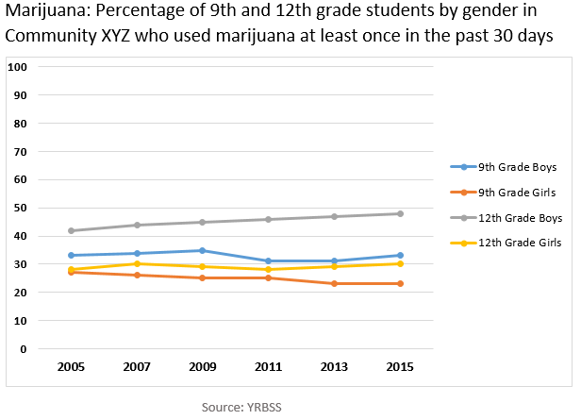

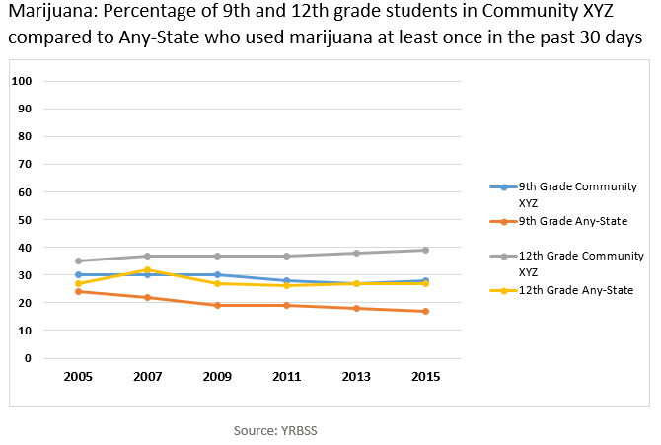





**INFORMATION SHEET 2.8 – EXAMPLES OF DATA TO COLLECT**

Once a community has assessed its problems and determined which one is a priority to address, their next task involves collecting data on the risk and protective factors in their community for that problem. This is a crucial part of the assessment step because the interventions a community selects will be based on these risk and protective factors.

#### Examples of data to collect on risk factors for underage drinkingiv

|  |  |
| --- | --- |
| **RISK FACTORS FOR UNDERAGE DRINKING** | **DATA TO COLLECT (DATA INDICATORS)** |
| Low perception of harm  from alcohol use | * Student reports on perception of risk of alcohol on youth surveys |
| Social norms that accept  and/or encourage underage drinking | * Student reports on peer norms * Student reports on parental attitudes about underage drinking * Community resident reports on community norms about underage drinking |
| Easy retail access | * Number of liquor outlets * Number of citation or violations for sales to minors * Students’ or parents’ self-reported perception of availability – surveys or focus groups * Number of successful alcohol buys |
| Low enforcement of alcohol laws | * Liquor law violations and citations   + Number   + Location * Self-reported attitudes towards enforcement * Ratio of arrests to convictions for legal violations * Sentencing patterns by judges |
| Easy social access | * Number of house parties * Number of public events where alcohol is served |
| Low or insufficient parental monitoring | * Student surveys on risk and protective factors * Percent of single-head households * Parent reports on monitoring * Involvement with social services * Focus groups |

**Examples of data to collect on protective factors for underage drinking**

|  |  |
| --- | --- |
| **PROTECTIVE FACTORS FOR UNDERAGE DRINKING** | **DATA TO COLLECT (DATA INDICATORS)** |
| Low sensation seeking personality characteristicv | * Self-reported perception of risk related to alcohol, tobacco and other drugs * Self-report of high risk behaviors in the last six months |
| Fewer positive expectations of alcoholvi | * Self-reported surveys on expectations of alcohol use |
| Prosocial activities (i.e. volunteering)v ii | * Student reports of participation in prosocial activities |
| Fewer friends who use  substancesv | * Self-reported proportion of how many of their closest friends use alcohol (scale) |
| Parents’ disapproval of  substance misuse and other deviant behaviorv iii | * Student reports on parental attitudes about underage drinking * Self-reported perceptions of consistent parental non-use messages * Self-reported perceptions of familial connectedness and support |
| Positive opportunities to belongix | * Self-reported surveys on opportunities they are aware of in school and/or community |

**WORKSHEET 2.9: ACTIVITY – MATCH UP**

**Purpose of Activity –** For certain risk and protective factors, identify the data and the sources for that data

#### Instructions –

1. Select three risk factors and one protective factor for underage drinking from the list below. Write them on the accompanying chart (on the next page).
2. Determine which data indicators from the list below would fit with each of the risk and protective factors you selected. Write this information on the chart.
3. Identify the source for the data, and write it on the chart.

|  |  |  |  |
| --- | --- | --- | --- |
| **1. Risk Factors for Underage Drinking** | **2. Protective Factors for Underage Drinking** | **3. Data Indicators** | **4. Sources of Data** |
| * Easy retail availability * Easy social access * Low perception of harm * Low enforcement of alcohol laws and policies * Alcohol promotion * Low commitment to school * Social norms that accept and/or encourage underage drinking * Parent or sibling alcohol use (or perception of use) * Limited or no parental monitoring (or perception of monitoring) | ➢Low sensation seeking  ➢Positive opportunities to belong  ➢Fewer positive expectations of alcohol  ➢Prosocial activities  ➢Fewer friends who use substances  ➢Parents’ disapproval of substance misuse and other deviant behavior  ➢Personal importance of religion | * Number of liquor outlets * Students’ or parents’ self-reported perception of availability * Number of successful alcohol buys * Number of house parties * Number of public events where alcohol is served * Number of ads on public transportation (print media) * Liquor law violations and citations * Self-reported attitudes towards enforcement * Self-reported surveys on expectations of alcohol use | * Health   departments   * Police   departments or courts   * Department of Social Services * Social service agencies * Schools, districts, or state departments of education * Municipal government * Other:   _____________ |

|  |  |  |  |
| --- | --- | --- | --- |
| * Low parental care or involvement |  | * Rates of absenteeism, tardiness, expulsions, detentions, and dropout rates * Self-reported perception of risk related to alcohol, tobacco and other drugs * Self-report of high risk   behaviors in the last six months   * Student reports on peer norms * Student reports on parental attitudes about underage drinking * Student reports on parental or sibling abuse * Parent reports on monitoring * Family involvement with social services * Self-reported perceptions of familial connectedness and support * Self-reported importance of religion (scale) |  |

|  |  |  |
| --- | --- | --- |
| **RISK/PROTECTIVE FACTOR**  **#1:** |  |  |
| **DATA INDICATORS** |  | **SOURCES** |
|  |  |  |
|  |  |  |
|  |  |  |
|  |  |  |
|  |  |  |
| **RISK/PROTECTIVE FACTOR**  **#2:** |  |  |
| **DATA INDICATORS** |  | **SOURCES** |
|  |  |  |
|  |  |  |
|  |  |  |
|  |  |  |
|  |  |  |
| **RISK/PROTECTIVE FACTOR**  **#3:** |  |  |
| **DATA INDICATORS** |  | **SOURCES** |
|  |  |  |
|  |  |  |
|  |  |  |
|  |  |  |
|  |  |  |

## INFORMATION SHEET 2.10 – ASSESSING CAPACITY

Capacity refers to resources and readiness:

* + The **resources** (programs, organizations, people, money, expertise, etc.) a community has to address its substance abuse problems
  + How **ready** the community is to take action and commit its resources to addressing these problems

# Resources

Communities need to assess the various types and levels of resources that it has available to address identified substance abuse problems. Looking at existing resources in a community utilizes an asset-based approach to prevention planning, rather than focusing on deficits and gaps.

Resources to consider:

**Fiscal resources** – This refers to the money that communities can bring to prevention efforts, as well as other things that cost money but can often be obtained for free, including:

* + Grants/donations
  + Computer hardware/software
  + Meeting space, food, photocopying
  + Promotion/advertising

**Human resources –** This refers to the people who can assist with prevention in some way:

* + Staff with the right credentials, training, experience, and expertise to address all aspects of prevention—leaders and staff may need to be hired or may require additional training and technical assistance in certain areas.
  + Consultants and/or volunteers who can support or supplement staff expertise (these individuals may need to be recruited to take on some of the tasks involved with developing and implementing a comprehensive prevention plan)
  + Stakeholders, including members of the population that the intervention(s) will focus on
  + Other partners who can provide additional expertise, necessary services, and/or connections to your target population
  + Local champions willing to back your prevention efforts

**Organizational resources** – This refers broadly to the structures within an organization that are deeply connected to a community’s substance abuse prevention goals, such as:

* + Vision and mission statements as well as guidelines for decision-making
  + Clear and consistent organizational patterns and policies
  + Adequate fiscal resources to implement a prevention program as it is planned
  + Hardware and other technology tools

Other resources that are useful but frequently overlooked include:

* + Community efforts to address prevention issues
  + Community awareness of those efforts
  + Specialized knowledge about prevention research, theory, and practice
  + Practical experience working with particular populations
  + Knowledge of the ways local politics and policies help or hinder prevention efforts

# Readiness

Assessing readiness involves looking at how ready a community is to:

* + Accept that a substance abuse problem needs to change
  + Take action to change the problem

It’s necessary to think critically about who really needs to function at a high level of readiness for your prevention initiative to be effective. The following are some key groups to consider:

* + **Prevention task force members –** Often charged with the responsibility of spearheading prevention efforts, task force members should function at a high level of readiness. Furthermore, task force members must be ready themselves before they can begin to promote readiness among others. It is critical, then, that task force members understand the community’s priority problems and genuinely understand and support each step of the SPF process.
  + **Influential community leaders –** These may be key stakeholders such as the chief of police, the heads of the local Board of Health and Licensing Board, and the superintendent of schools. They include individuals who can either make or break your initiative. For example, in one community the schools and parents wanted police to inform them when underage youth were found drinking at parties; however, the chief of police was resistant because he thought young people needed safe places to have fun without the risk of getting in trouble. A prevention initiative targeting underage drinking in this community would need to understand and promote the chief’s level of readiness in order to be effective.
  + **Vocal community groups –** Parents, young people, special interest groups, activists, and others in your community may feel strongly about substance use, the related problems in the community, or how they are addressed. For example, the police in one community were severely reprimanded by the attorney general for failing to enforce underage drinking laws. As a result, the chief of police instructed officers to strictly enforce these laws. This action was met with great resistance from parents who were more concerned about their children getting into college than about their drinking habits. In this case, an influential community leader was functioning at a high level of readiness, but an important and vocal segment of the community was not.

# Readiness Models

Different models of readiness can be used to determine where a community is along the readiness continuum. The Tri-Ethnic Center Community Readiness model identifies nine stages:x

**STAGE 1 – Community Tolerance/No Knowledge:** The community or leaders do not generally recognize substance abuse as a problem. “It’s just the way things are” is a common attitude.

Community norms may encourage or tolerate the behavior in social contexts. Substance abuse may be attributed to age, sex, racial, or class groups.

**STAGE 2 – Denial:** There is some recognition by at least some members of the community that the behavior is a problem, but little or no recognition that it is a local problem. Attitudes may include, “It’s not my problem” or “We can’t do anything about it.”

**STAGE 3 – Vague Awareness:** There is a general feeling among some in the community that there is a local problem and that something ought to be done, but there is little motivation to do anything. Knowledge about the problem is limited. No identifiable leadership exists, or leadership is not encouraged.

**STAGE 4 – Preplanning:** There is clear recognition by many that there is a local problem and something needs to be done. There is general information about local problems and some discussion. There may be leaders and a committee to address the problem, but no real planning or clear idea of how to progress.

**STAGE 5 – Preparation:** The community has begun planning and is focused on practical details. There is general information about local problems and about the pros and cons of prevention programs, but this information may not be based on formally collected data. Leadership is active and energetic. Decisions are being made and resources (time, money, people, etc.) are sought and allocated.

**STAGE 6 – Initiation:** Data are collected that justify a prevention program. Decisions may be based on stereotypes rather than data. Action has just begun. Staff is being trained. Leaders are enthusiastic, as few problems or limitations have occurred.

**STAGE 7 – Institutionalization/Stabilization:** Several planned efforts are underway and supported by community decision makers. Programs and activities are seen as stable, and staff is trained and experienced. Few see the need for change or expansion. Evaluation may be limited, although some data are routinely gathered.

**STAGE 8 – Confirmation/Expansion:** Efforts and activities are in place and community members are participating. Programs have been evaluated and modified. Leaders support expanding funding and program scope. Data are regularly collected and used to drive planning.

**STAGE 9 – Professionalism/High Level of Community Ownership:** The community has detailed, sophisticated knowledge of prevalence and risk and protective factors. Universal, selective, and indicated efforts are in place for a variety of focus populations. Staff is well trained and experienced. Effective evaluation is routine and used to modify activities. Community involvement is high.

## WORKSHEET 2.11: CASE STUDY ACTIVITY – DETERMINING RESOURCES & READINESS

**Purpose of Activity –** Connect the concepts of resources and readiness to the case study

#### Background –

**Community Overview**

Community XYZ is located in an urban setting with a population that is 76% white, 15% Latino, 6% African American, and 3% Asian/Pacific Islander. Twenty years ago the community was thriving and considered to be the center for manufacturing for the state. Over the last five years, manufacturing businesses have either closed down or moved out of the area and the state. This has left the community economically depressed with a high unemployment rate. Many of the young people growing up in the community leave to go to college and/or find work.

**Task Force Overview**

The Substance Abuse Prevention Task Force was started by a group of concerned parents seven years ago. There were several incidents that caused concern, including the death of a teen due to alcohol poisoning. The task force consists of 25 parents, a representative from the mayor’s office, a pediatrician, several representatives from the Women’s Guild (an organization for women over age 65), representatives from a Health Task Force serving the Latino community, local artists, a newspaper reporter, and youth from the local church youth group.

## Resources

Within this urban setting, many of the key stakeholders are involved in the task force.

The churches have been active in youth prevention efforts, including an interfaith prevention education series for parents and weekly prevention education tips posted in church bulletins. Community XYZ is home to one of the oldest African American churches in country. This church is a strong leader in the community interfaith group. Additionally, the local churches and the local community health center have partnered to become a resource and safe haven for new immigrants to the community. Over the last several months, the interfaith group has established a practice of not serving alcohol at events sponsored by the faith community. Several other organizations have also agreed not to serve alcohol at their sponsored events when young people are present.

It is well known that Community XYZ has created an environment in which its community members feel safe. For example, the town has a huge park that is a gathering place for residents to bike, jog, use a nature-focused playground, and picnic. In addition, a local resident has a Facebook blog that

reports on community events and local happenings, and posts features about people in the community.

The Latino community includes families, business owners, cultural and educational organizations, and a Health Task Force made up physicians, former physicians, and other medical professionals concerned about the health-related issues. Some members from the Health Task Force are also members of the Substance Abuse Prevention Task Force. Information and events are shared across the two groups, and they have worked on some joint projects.

Community XYZ has several community-wide events including a Fall Festival, Summer Arts Festival, and a Chinese New Year’s Celebration. The Fall Festival is sponsored by local and national businesses, including businesses from the alcohol industry. This event includes an Oktoberfest Beer Garden where it is easy for underage youth to get to alcohol. The local hospital has reported several hospitalizations due to alcohol poisoning that correspond with these events.

The task force has had an excellent relationship with the editor of the local paper. At the suggestion of the task force chair, the newspaper editor provided the task force with a monthly column to write about kids and prevention issues. This column has become a great vehicle to begin educating the public about substance abuse issues, and readers have been encouraged to send in questions. In addition, using youth volunteers, the task force started an educational website with pages for kids as well as parents.

The task force has a positive relationship with the courts, and has assisted in developing programs targeted at youth in the juvenile justice system. The community also has a youth drug court, where youth who are found guilty for alcohol and/or other drug offences receive case management and other services, such as brief intervention, screening, and referrals.

Over the last several years the task force has tried to build a positive relationship with the public school system. The focus of the outgoing superintendent of schools has been on scholastics over social and emotional health. In addition, budget cuts in the past few years have significantly reduced the size of the guidance department and the health education program.

While there continues to be a distant relationship between the school administration and the task force, its elementary schools are the hub of community activity for young families. All elementary schools have active Parent and Teach Organizations (PTOs), where they host family focused out-of- school activities at least twice a month. Parents also have a choice of which elementary school they wish their child to attend, each school having unique offerings (e.g., a Spanish immersion program, focus on science skills). Many clubs such as sports, scouting and the arts are hosted by the local schools as well. The schools also have a cross-age teaching program in robotics and other sciences where high school students mentor elementary and middle school children. Since the influx of new immigrants, children of all ages have a positive experience of the diversity of many ethnic groups in their school and out-of-school activities.

## Readiness

The readiness to address the problem of alcohol and other drugs is not consistent across the community. There are key stakeholders such as the faith community, health care providers, youth-serving agencies, newspapers, and a growing constituency of parents that see underage drinking as an important issue to be addressed. There have been several incidents of youth injured while drinking alcohol. The most recent involved the drowning of an adolescent boy intoxicated at a pool party. This has many parents in the community concerned about the issue. Other sectors, such as the school, do not see underage drinking as a problem and do not believe that the schools should be focused on such efforts.

There are several sectors, such as the police and business, that are aware of the problems of alcohol and other drugs but are not sure of their role in solving the problem.

#### Instructions –

1. Get into your case study groups.
2. Review the information on resources and readiness for this case on the previous two pages.
3. Use the information provided in the case to determine the resources, resources gaps, and readiness for underage drinking in this case.
4. Record your answers below.

|  |  |  |
| --- | --- | --- |
| **Resources** | **Resource Gaps** | **Readiness** |
|  |  |  |

i Friis, R. H., & Sellers, T. A. (2009). *Epidemiology for public health practice* (4th ed.). Sudbury, MA: Jones & Bartlett Publishers, LLC.

ii U.S. Department of Health and Human Services, Centers for Disease Control and Prevention. (2006). Principles of Public

Health Practice in Epidemiology, Third Edition: An Introduction to Applied Epidemiology and Biostatistics. [Self -study Course SS1978]. Retrieved from [http://w](http://w/) ww.cdc.gov/osels/scientific_edu/SS1978/#2

iii Wu, L.-T., Korper, S. P., Marsden, M. E., Lew is, C., & Bray, R. M. (2003). Use of Incidence and Prevalence in the

Substance Use Literature: A Review . Rockville, MD: Substance Abuse and Mental Health Services Administration, Office of Applied Studies.

iv Substance Abuse and Mental Health Services Administration. (2017). Conceptual fit: Sample risk factors and

interventions for underage drinking. Retrieved from [https://w w w.samhsa.gov/capt/tools-learning-resources/sample-risk-](https://www.samhsa.gov/capt/tools-learning-resources/sample-risk-factors-interventions-underage-drinking) [factors-interventions-underage-drinking](https://www.samhsa.gov/capt/tools-learning-resources/sample-risk-factors-interventions-underage-drinking)

v White, H., McMorris, B., Catalano, R., Fleming, C., Haggerty, I., & Abbott, R. (2006). Increases in alcohol and marijuana use during the transition out of high school into emerging adulthood: The effects of leaving home, going to college, and high school protective factors. *Journal of Studies on Alcohol, 67*, 810-822.

vi Courtney, K. E., & Polich, J. (2009). Binge drinking in young adults: Data, definitions, and determinants. *Psychological Bull, 135*(1), 142-156.

vii Wechsler, H., & Nelson, T. (2008) What w e have learned from the Harvard School of Public Health College Alcohol

Study: Focusing attention on college student alcohol consumption and the environmental conditions that promote it.

*Journal of Studies on Alcohol and Drugs, 69*(4), 481-490.

viii Jessor, R., Costa, F., Krueger, P., & Turbin, M. (2006). A developmental study of heavy episodic drinking among college students: The role of psychosocial and behavioral protective and risk factors. *Journal of Studies on Alcohol, 67*, 67-94.

ix Napoli, M., Marsiglia, F. F., & Kulis, S. (2003). Sense of belonging in school as a protective factor against drug abuse

among Native American urban adolescents. *Journal of Social Work Practice in the Addictions, 3*(2), 25–41.

x Edw ards, R. W., Jumper-Thurman. P., Plested, B. A., Oetting, E. R., & Sw anson, L. (2000). Community readiness:

Research to practice. Journal of Community Psychology, 28(3), 291-307. Retrieved from [http://w w w.colostate.edu/Dept/TEC/article3.htm](http://www.colostate.edu/Dept/TEC/article3.htm)