**Crafting Concise Communication**

Agency or Program Background Information:

What is the mission or purpose of your agency or program?

What is the history?

What are the achievements?

What is the Vision statement?

What is Mission statement? (What you do, how you do it, and why you do it)

Developing Your Elevator Speech

What might catch someone’s attention?

***Write*** your hook *on the back of this paper*.

***Write*** your elevator speech *on the back of this paper*.

What is the intent of your message?

***Read*** it out loud.

Is it brief, clear and understandable?

***Count*** the number of words- __________

Practice #1- Were you able to deliver your elevator speech in under one minute?

Polish Your Elevator Speech

How well did your 1st delivery go?

Did your elevator speech have the impact and effect you wanted?

What needs to be re-phrased?

What needs to be cut out?

What needs to be added?

What’s your ask?

***Write*** the “ASK” *on the back of this paper*.

Practice #2- Were you able to deliver your elevator speech in under one minute?

How well did your 2nd delivery go?

What can be simplified?

What are you discovering?

Practice, practice, practice!

Write your elevator speech on several index cards and place them around

your office, car, mirror, etc. and speak it out loud 3 or more times per day for 30 days!

[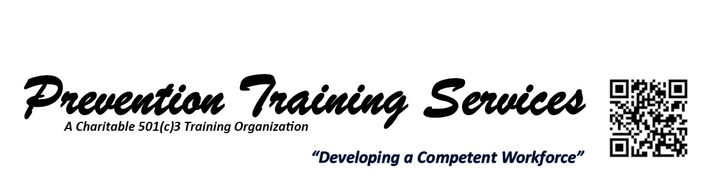](http://www.preventiontrainingservices.com/wp)