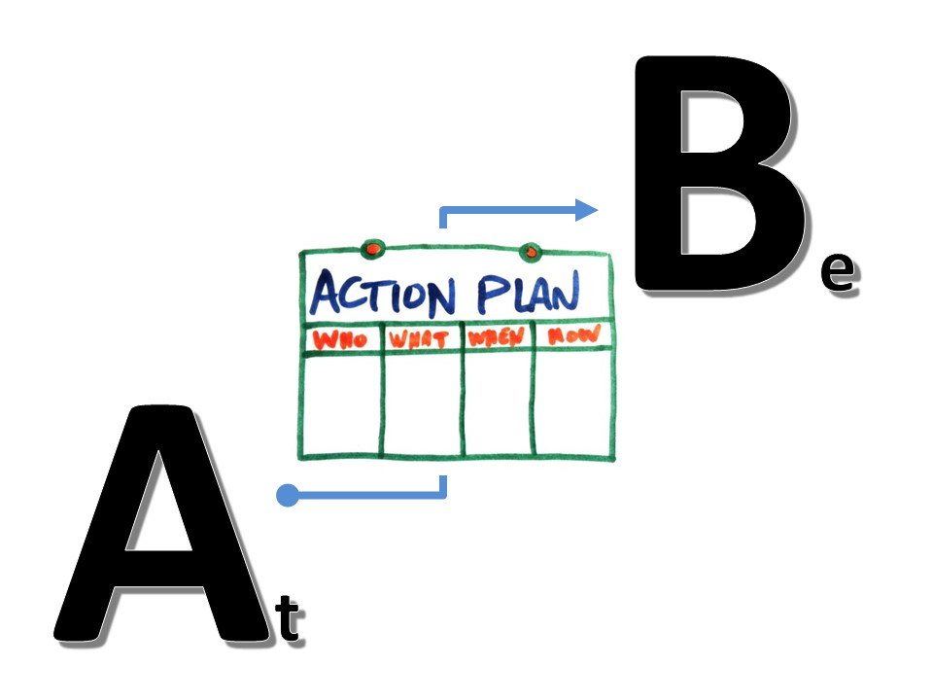

Where do we want to be?

Where are we at?

How will we get there?

Be?

Where do we want to be? ***Vision***

What would we like to see changed? ***Issues/ Problems***

What does success look like? ***Results***

At?

**Where are we right now?**

*Operationalize prevention strategies, Create and maintain regional and county level logic models, Organize and maintain a Regional Prevention Task, Organize, recruit and conduct region-wide meetings/conferences/forums, etc.*

What is the current situation in our community? *Assessment*

*Local needs assessment, regional data, archival data*

Who is on our Task Force? How active are the members? Who is missing?

What resources do we have? *Assess Capacity*

Is the community ready? *Readiness Assessment*

Are we ready?

*Certified staff and trained volunteers*

What additional resources do we need? *Build Capacity*

*Market and promote prevention capacity development,*

Who is already working on the situation we want to change? *Partnerships*

How can we collaborate with them? *Build Capacity*

*Empower others to increase prevention efforts, form linkages, educate community leaders and elected officials, promote utilization of evidence-based practices, provide consultation and technical assistance, and increase levels of involvement*

How involved is the community? *Build Capacity*

*Build community investment and ownership, plan for sustaining the efforts and progress made in community capacity development,*

Which risk & protective factors are we focusing on?*Planning*

*Use of the risk and protective factors as the foundation for prevention efforts.*

What else do we need?

*A strategic plan to reduce incidence and prevalence of substance abuse rates in the state/region and impact the National Outcome Measures.*

How will we get there?

**Strategic Planning Template**

Engage stakeholders:

Program recipients

Community stakeholders

Board members

Staff & volunteers

Define your mission and vision:

What is our vision statement?

What is our mission statement?

How will we obtain it?

Use data and research:

Community assessment

Key informant interviews

Archival data

S.W.O.T. Analysis

Strengths

Weaknesses

Opportunities

Threats

Identify your goals and objectives:

## What are we planning to do?

## The goal of the program is… (What the program is trying to achieve)

## What is our objective? (Time bound, specific & measurable)

## What activities need to be completed to achieve the objective?

What are the process measures?

## What will keep us from achieving the objective?

Create an action plan:

## WHO will do WHAT by WHEN?

## Person - Activity - Deadline

## Who will be accountable that the activity is completed?

## Who will be responsible to complete the activity?

Review and revise:

Plan created on:

Reviewed on:

Revised on:

**Strategic Planning**

**Engage stakeholders:**

Program recipients

Community stakeholders

Board members

Staff & volunteers

***The Strategic Prevention Framework is reliant on and encourages a team approach:***

*Each step of the SPF requires-and greatly benefits from-the participation of diverse community partners.*

Cultural Competence Guiding Principal:

To ensure that prevention practices produce positive outcomes for members of diverse population groups, communities must engage in an inclusive and culturally appropriate approach to identifying and addressing their substance misuse problems.

SAMHSA has identified the following cultural competence principles for prevention planners:

* ***Include the priority population in all aspects of prevention planning***
* Use a population-based definition of community (i.e., let the community define itself)
* Stress the importance of relevant, culturally appropriate prevention approaches
* Employ culturally competent evaluators
* Promote cultural competence among program staff, reflecting the communities they serve
* ***Make community representation in the planning process a priority***
* ***Involve members of the focus population as active participants and decision-makers***

Sustainability Guiding Principles:

1. ***Engage partners*** who represent and work with sub-populations experiencing behavioral health disparities in your sustainability planning efforts.
2. Sustain processes that have successfully engaged members of these populations.
3. Sustain programs that produce positive outcomes for these populations.

***How the SPF Contributes to Sustainability***

**Assessment:** During assessment, practitioners begin making decisions based on a clear understanding of local prevention needs. They also begin ***building relationships*** with data keepers and stakeholders who can playimportant roles in supporting and sustaining local prevention effortsover time.

**Capacity:** ***Intentional capacity building at all levels*** helps to ensure that successfulprograms are sustained within a larger community context, andtherefore less vulnerable to local budgetary and political fluctuations.

Effective capacity building increases an organization’s or community’s ability to respond to changing issues with innovative solutions.

Building capacity also involves promoting public awareness and support for evidence-based prevention, and engaging partners and cultivating champions who will be vital to the success—and sustainability—of local prevention efforts.

**Planning:** When developing a comprehensive approach to preventing substancemisuse, communities should consider the degree to which preventioninterventions fit with local needs, capacity, and culture: the better the fit,the more likely interventions are to be both successful and sustainable.

**Implementation:** By ***working closely with community partners*** to deliver evidence-basedprograms and practices as intended, closely monitoring and improvingtheir delivery, and celebrating “small wins” along the way, planners helpto ensure their effectiveness and begin to weave prevention into thefabric of the community.

**Evaluation:** Through process and outcome evaluation, communities can makeimportant mid-course corrections to prevention efforts, identify whichpractices are worth expanding and/or sustaining, and examine ongoingplans for—and progress toward—sustaining those practices that work.

By sharing evaluation findings, planners can also help build the support needed to expand and sustain effective interventions.

**Define your mission and vision:**

What is our vision statement?

What is our mission statement?

How will we obtain it?

**Establishing a Vision and Mission**6 is a process of coming together to set direction and focus for the group's efforts.

***Participating in this process helps a group begin with the end in mind,***

***and to stay focused on the results for which they are aiming.***

Establishing a vision - a statement of your dream or ideal conditions - and a mission - what you do and why - provides shared language and common purpose for targeted action and intervention. Establishing a Vision and Mission is a key process to help groups assess, prioritize, and plan for change.

**WHAT IS A VISION STATEMENT?** 7

Your vision is your dream.

It's what your organization believes are the ideal conditions for your community; that is, how things would look if the issue important to you were completely, perfectly addressed.

**WHAT IS A MISSION STATEMENT?**

An organization's mission statement describes *what* the group is going to do and *why* it's going to do that.

**Use data and research:**

Community assessment

Key informant interviews

Archival data

To conduct a comprehensive assessment of prevention needs, prevention professionals gather data about each of the following:

1. The nature of the substance misuse problem in the community and related harmful behaviors
2. Risk and protective factors that influence substance misuse problems, particularly those of high priority in the community
3. Community capacity for prevention, including readiness and available resources

**The nature of the substance misuse problem in the community and related harmful behaviors**

* ***What*** substance misuse problems (e.g., overdoses, alcohol poisoning) and related harmful behaviors (e.g., prescription drug misuse, underage drinking) are occurring in the community?
* ***How often*** are these substance misuse problems and related harmful behaviors occurring? Which ones are happening the most?
* ***Where*** are these substance misuse problems and related harmful behaviors occurring (e.g., at home or in vacant lots, in small groups or during big parties)?
* ***Who*** is experiencing more of these substance misuse problems and related harmful behaviors (e.g., males, females, youth, adults, members of certain cultural groups)?

Effective prevention focuses on reducing the risk factors and strengthening the protective factors specific to the priority problem in *your* community.

**S.W.O.T. Analysis**

What is happening in our community?

**Strengths:**

What does our community do well?

What is unique about our community?

What does our program do best in the community?

**Weaknesses:**

What can be improved in our community?

What can be improved in our program?

What resources could improve our performance?

**Opportunities:**

What opportunities are there in our community that are not being utilized?

Do we have “everyone” at the table when we plan an event?

What gaps in service are there?

**Threats:**

What changes are there in the community that are out of our control?

What changes are happening in our community that are a cause for concern?

**Identify the goals and objectives:**

## What are we planning to do?

Which risk & protective factors are we focusing on?

## The goal of the program is… (What the program is trying to achieve)

## What is our objective? (Time bound, specific & measurable)

## What activities need to be completed to achieve the objective?

What are the process measures?

## What will keep us from achieving the objective?

## What does success look like?

**Community Readiness for Change** 8

Stage 1: No Awareness  *“Kids drink and get drunk.”*

Stage 2: Denial/Resistance  *“We can’t (or shouldn’t) do anything about it!”*

Stage 3: Vague Awareness  *“Something should probably be done, but what?*

Stage 4: Preplanning “*This is important. What can we do?”*

Stage 5: Preparation  *“I will meet with our funder tomorrow.”*

Stage 6: Initiation  *“This is our responsibility”*

Stage 7: Stabilization  *“We have taken responsibility”*

Stage 8: Confirmation/Expansion  *“How well are our current programs working?”*

Stage 9: High Level of Community Ownership

*“These efforts are an important part of the fabric of our community.”*

**Seven Strategies for Community Change**

***Individual Change Strategies***

**1. PROVIDING INFORMATION** – Educational presentations, workshops or other data presentations (e.g., public announcements, brochures, community meetings or social media).

**2. BUILDING SKILLS** – Workshops or other activities designed to increase the skills of participants, members and staff needed to achieve population-level outcomes (e.g., training, technical assistance, distance learning, strategic planning retreats and curricula development).

**3. PROVIDING SUPPORT** – Creating opportunities to support people to participate in activities that reduce risk or enhance protection (e.g., providing alternative activities, mentoring, referrals, support groups or clubs).

***Environmental Change Strategies***

**4. ENHANCING ACCESS/REDUCING BARRIERS** – Improving systems and processes to increase the ease, ability and opportunity to utilize those systems and services (e.g., ensuring childcare, transportation, safety, special needs and cultural and language sensitivity).

**5. CHANGING CONSEQUENCES** (INCENTIVES/DISINCENTIVES) – Increasing or decreasing the probability of a specific behavior that reduces risk or enhances protection by altering the consequences for performing that behavior (e.g., increasing public recognition for deserved behavior, individual and business rewards, scholarships, citations, fines or revocations/loss of privileges).

**6. PHYSICAL DESIGN** – Changing the physical design or structure of the environment to reduce risk or enhance protection (e.g., parks, landscapes, signage, lighting or outlet density).

**7. MODIFYING/CHANGING POLICY** – Formal change in written procedures, by-laws, proclamations, rules or laws with written documentation and/or voting procedures (e.g., workplace initiatives, law enforcement procedures and practices, public policy actions and systems change within government, communities and organizations).

Effective Communication and Engagement

**Communications Strategies**- public education, social marketing, media advocacy, and media literacy- can be used to influence community norms, increase public awareness, and attract community support for a variety of prevention issues.

*Messages communicated through the media influence how the public thinks and behaves.*

**Public education** is designed to increase the public’s knowledge and awareness of a particular health issue. Public education campaigns may combine public service announcements (PSAs) on television, radio, or online with billboards and posters. Familiar public education slogans include “Friends don’t let friends drive drunk” and “A mind is a terrible thing to waste.”

**Social marketing** involves using advertising principles to change social norms and promote healthy behaviors. Like public education, social marketing uses multiple media channels to message targeted groups of individuals. However, social marketing campaigns do more than provide information. They try to persuade people to adopt a new behavior by showing them the benefit they’ll gain by doing so.

**Media advocacy** attempts to shape the way social issues are discussed in the media. The goal is to build support for changes in public policy. By working directly with outlets to change both the amount of coverage the media provides and the content of that coverage, media advocates hope to influence the way people talk and think about a social or public policy.

**Media literacy** teaches young people critical viewing skills. This approach seeks to help children and teenagers analyze, understand, and evaluate the media messages they encounter.

**Create an Action plan:**

## WHO will do WHAT by WHEN?

## Person - Activity - Deadline

## Who will be accountable that the activity is completed?

## Who will be responsible to complete the activity?

Review and revise:

Plan created on:

Plan reviewed on:

Plan revised on:

**A Logic model** is a graphic representation that clearly lays out the logical relationships between the problem to be addressed, program activities, outputs, and outcomes.

Problem Statement: *What problem does your program address?*

Goal: *What is the overall purpose of your program?*

Resources: *What do you have to work with?*

Activities: *What will you do with your resources?*

Outputs*: What are the tangible products of your activities?*

Outcomes: *What changes do you expect to occur as a result of your work?*

Outcomes Chain *If/ then…*

External Factors: *Other influences on program results*

Theory of Change and the Logic Model

Rationales: *How does change occur in your field?*

Assumptions: *Why will your program work?*

**Example:**

Problem Statement: Youth have easy social access to alcohol

Goal: Reduce 30 day underage drinking rates by 10%

Resources: Community Coalition & Other Partnerships

Activities: Parent education campaign

Outputs: 85% of adults in our community will receive information about adolescent alcohol abuse and its effect on the brain.

Outcomes: 50% of participants surveyed will report friends and relatives as the primary sources where people under the age of 21 obtain alcohol compared to the 68.83 % today.

Outcomes Chain: If we educate the public about adolescent alcohol abuse then

the public will have a change in perception of harm which will lead to a reduction in making alcohol available to minors.

References

(1) National Research Council and Institute of Medicine. (2009). *Preventing Mental, Emotional, and Behavioral Disorders Among Young People: Progress and Possibilities. Washington, DC: The National Academies Press, pg Glossary xxvii.*

(2) Substance Abuse and Mental Health Services Administration. (2011). *Leading change: A plan for SAMHSA’s role* *and actions 2011-2014 (HHS Publication No. (SMA) 11-4629). Rockville, MD: Author.*

(3) NIDA. 2024, January 5. Drug Misuse and Addiction. Retrieved from <https://nida.nih.gov/publications/drugs-brains-behavior-science-addiction/drug-misuse-addiction> on 2024, May 3

4) <https://www.samhsa.gov/sites/default/files/20190718-samhsa-risk-protective-factors.pdf>

5) <https://www.samhsa.gov/sites/default/files/20190620-samhsa-strategic-prevention-framework-guide.pdf>

6) Center for Community Health and Development. (n.d.). *Establishing a Vision and Mission.* University of Kansas. Retrieved May 17, 2024, from the Community Tool Box: <https://ctb.ku.edu/en/best-change-processes/establishing-a-vision-and-mission/overview>

7) Center for Community Health and Development. (n.d.). *Chapter 8, Section 2: Establishing a Vision and Mission.* University of Kansas. Retrieved May 17, 2024, from the Community Tool Box: <https://ctb.ku.edu/en/table-of-contents/structure/strategic-planning/vision-mission-statements/main>

8) Tri-Ethnic Center Community Readiness Handbook 2nd edition, 2014 <https://tec.colostate.edu/wp-content/uploads/2018/04/CR_Handbook_8-3-15.pdf>

Resources

<https://preventiontrainingservices.com/wp/resources/>

Beyond the Basics: <https://www.cadca.org/resources-center/>

Fostering Healthy Mental, Emotional, and Behavioral Development in Children and

Youth: A National Agenda (2019) <https://nap.nationalacademies.org/catalog/25201/fostering-healthy-mental-emotional-and-behavioral-development-in-children-and-youth>

Risk & Protective Factors: <https://youth.gov/youth-topics/risk-and-protective-factors>

Learn about the Strategic Prevention Framework <https://pttcnetwork.org/the-strategic-prevention-framework-spf/>

Logic Model: <https://www.innonet.org/news-insights/resources/logic-model-workbook/>

[Strategic Prevention Framework Guide](https://www.samhsa.gov/sites/default/files/20190620-samhsa-strategic-prevention-framework-guide.pdf) <https://www.samhsa.gov/sites/default/files/20190620-samhsa-strategic-prevention-framework-guide.pdf>

Focus on Prevention <https://store.samhsa.gov/sites/default/files/sma10-4120.pdf>

Community Engagement <https://store.samhsa.gov/sites/default/files/pep22-06-01-005.pdf>

What Works, What Doesn’t <https://www.hca.wa.gov/assets/program/px_tool_what_works_what_doesnt.pdf>

Identifying & Selecting Evidenced Based Interventions <https://preventiontrainingservices.com/wp/wp-content/uploads/identifying-and-selecting-evidence-based-interventions-samhsa-2009.pdf>

Drugs, Brains, and Behavior-The Science of Addiction <http://preventiontrainingservices.com/resources/sciofaddiction.pdf>

DEA Drugs of Abuse 2022 <https://www.dea.gov/sites/default/files/2022-12/2022_DOA_eBook_File_Final.pdf>

Prevention of Substance Use and Mental Disorders <https://www.samhsa.gov/find-help/prevention>

Evidence-Based Practices Resource Center <https://www.samhsa.gov/resource-search/ebp>

Evidenced- Based Prevention Strategies <https://nida.nih.gov/research-topics/prevention#evidence-based-prevention-strategies>

DEVELOPING A VISION AND MISSION STATEMENT from <https://ctb.ku.edu/en/table-of-contents/structure/strategic-planning/vision-mission-statements/tools>